* Task 1: Provision the lab environment
* Task 2: Configure the hub and spoke network topology
* Task 3: Test transitivity of virtual network peering
* Task 4: Configure routing in the hub and spoke topology
* Task 5: Implement Azure Load Balancer
* Task 6: Implement Azure Application Gateway

Task 1: Provision the lab environment

**Upload** and upload the **az104-06-vms-loop-template.json** and **az104-06-vms-loop-parameters.json** into the Cloud Shell home directory.

From the Cloud Shell pane run commands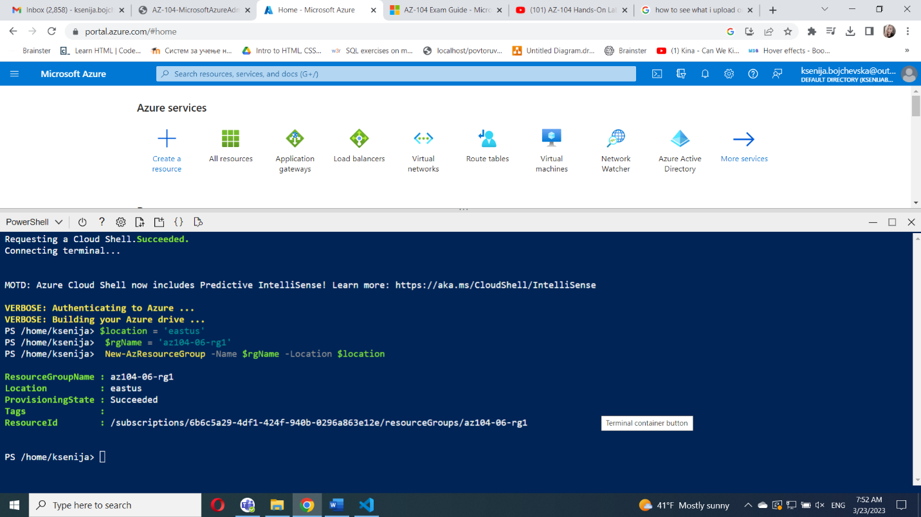

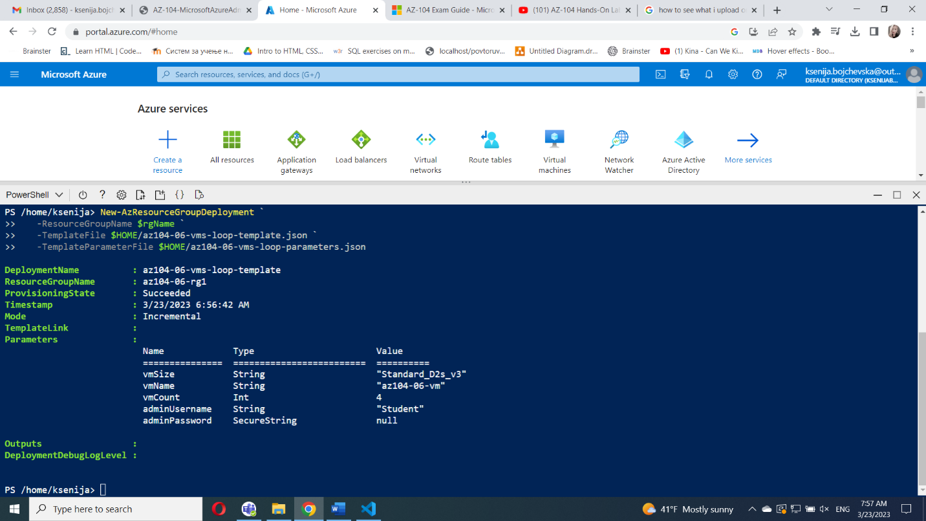

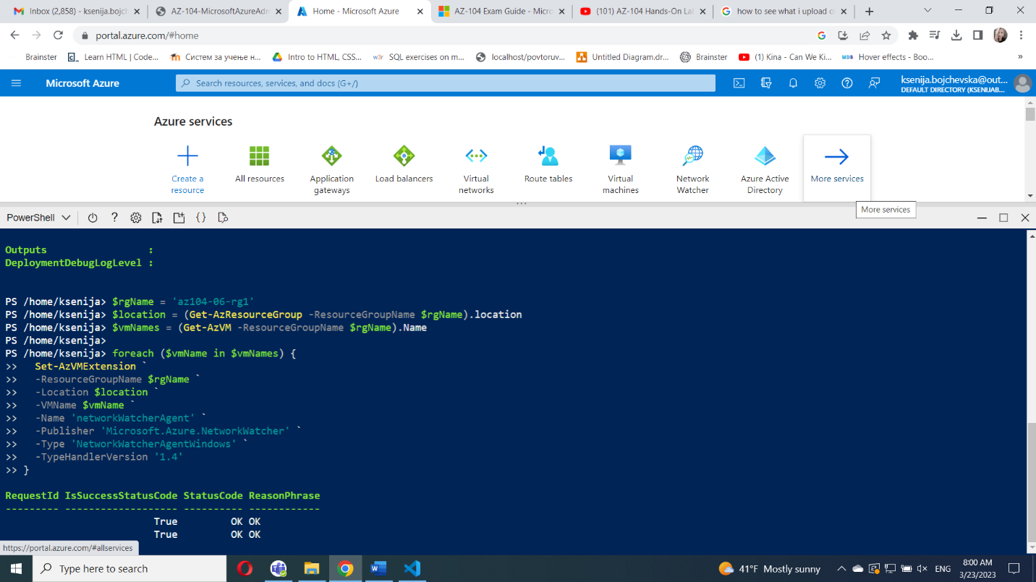

#### Task 2: Configure the hub and spoke network topology

Review the virtual networks you created in the previous task

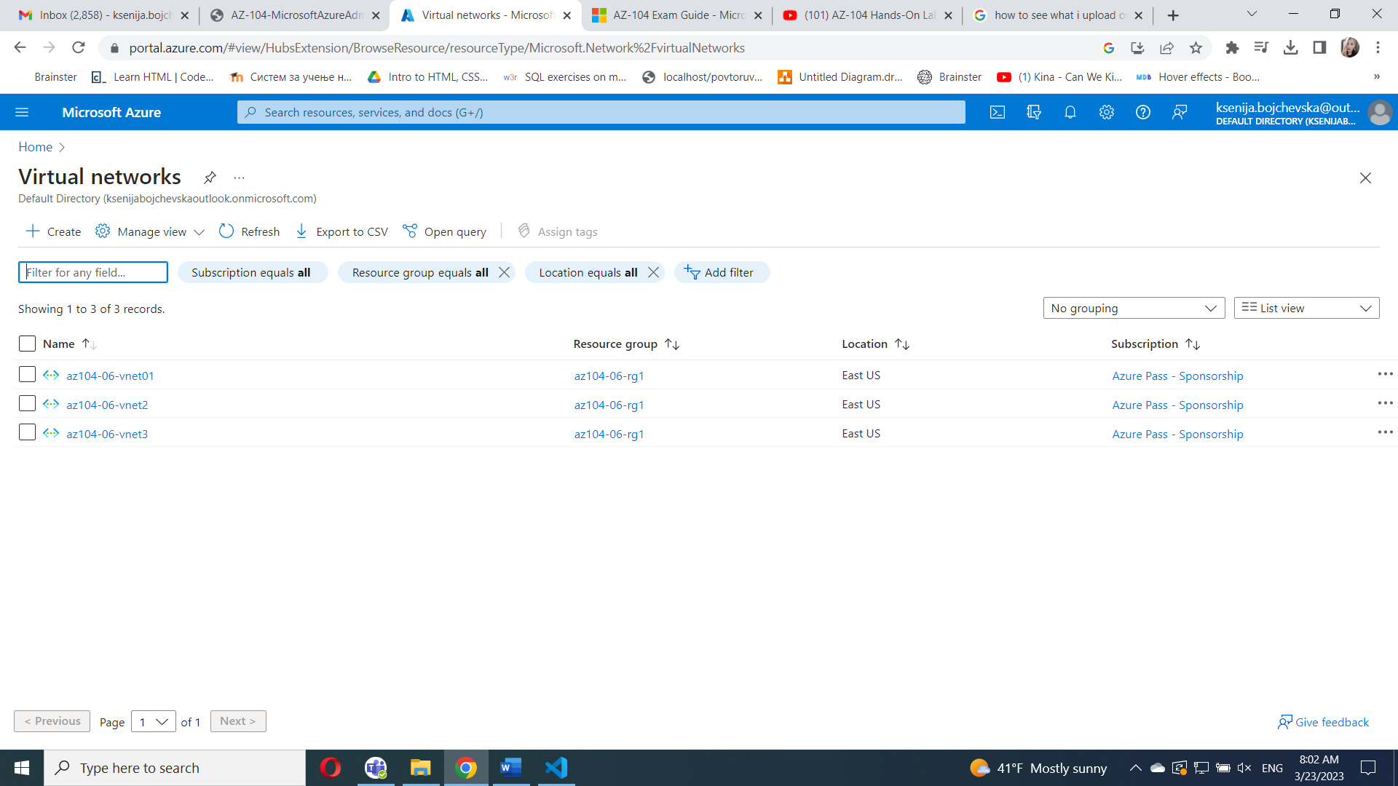

/subscriptions/6b6c5a29-4df1-424f-940b-0296a863e12e/resourceGroups/az104-06-rg1/providers/Microsoft.Network/virtualNetworks/az104-06-vnet2

/subscriptions/6b6c5a29-4df1-424f-940b-0296a863e12e/resourceGroups/az104-06-rg1/providers/Microsoft.Network/virtualNetworks/az104-06-vnet3

On the **az104-06-vnet01** virtual network blade, in the **Settings** section, add  **Peerings**

**az104-06-vnet01_to_az104-06-vnet2**

**az104-06-vnet01_to_az104-06-vnet3**

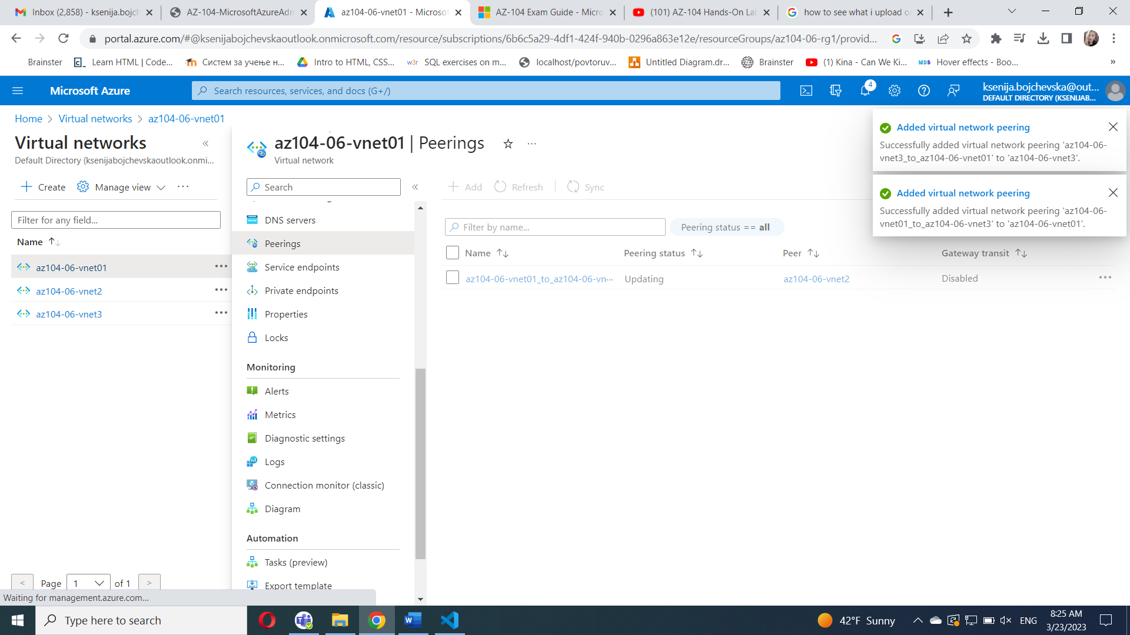

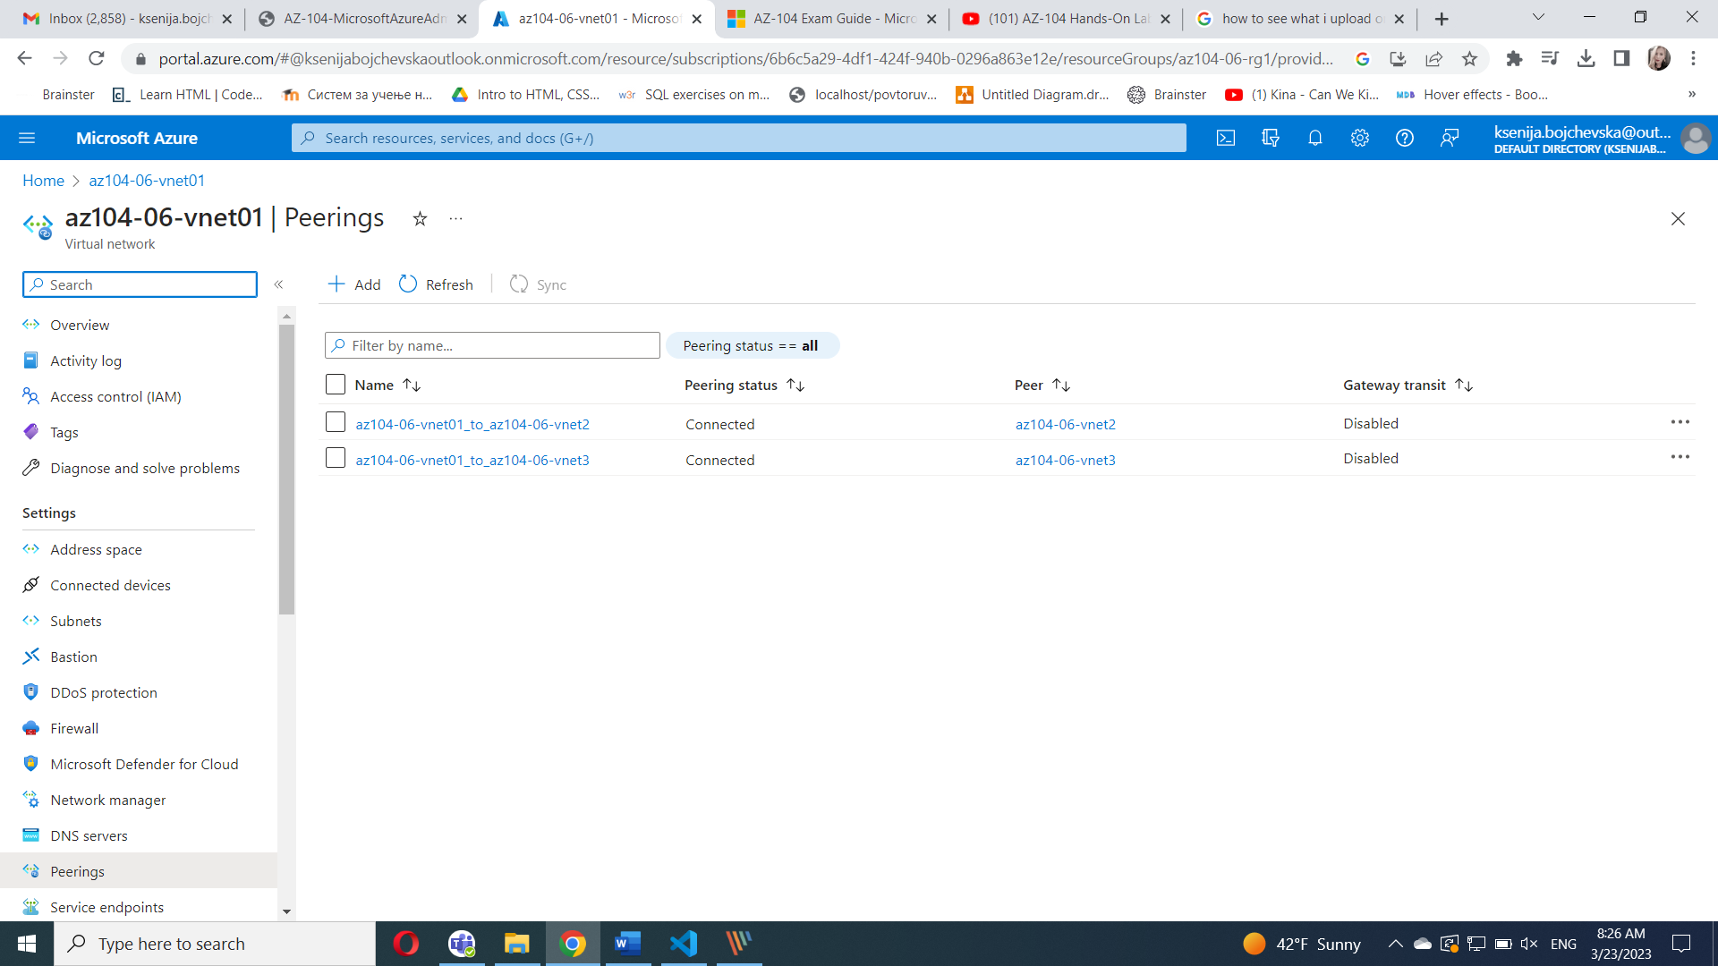

#### Task 3: Test transitivity of virtual network peering

#### 

#### 

#### 

#### Task 4: Configure routing in the hub and spoke topology

#### **On Virtual machines** blade, in the list of virtual machines, click **az104-06-vm0**, **Settings** section, click **Networking and** Set **IP forwarding** to **Enabled**

#### 

#### On the **az104-06-vm0** blade, in the **Operations** section, click **Run command** Install-WindowsFeature RemoteAccess -IncludeManagementTools

#### 

**And**

Install-WindowsFeature -Name Routing -IncludeManagementTools -IncludeAllSubFeature

Install-WindowsFeature -Name "RSAT-RemoteAccess-Powershell"

Install-RemoteAccess -VpnType RoutingOnly

Get-NetAdapter | Set-NetIPInterface -Forwarding Enabled

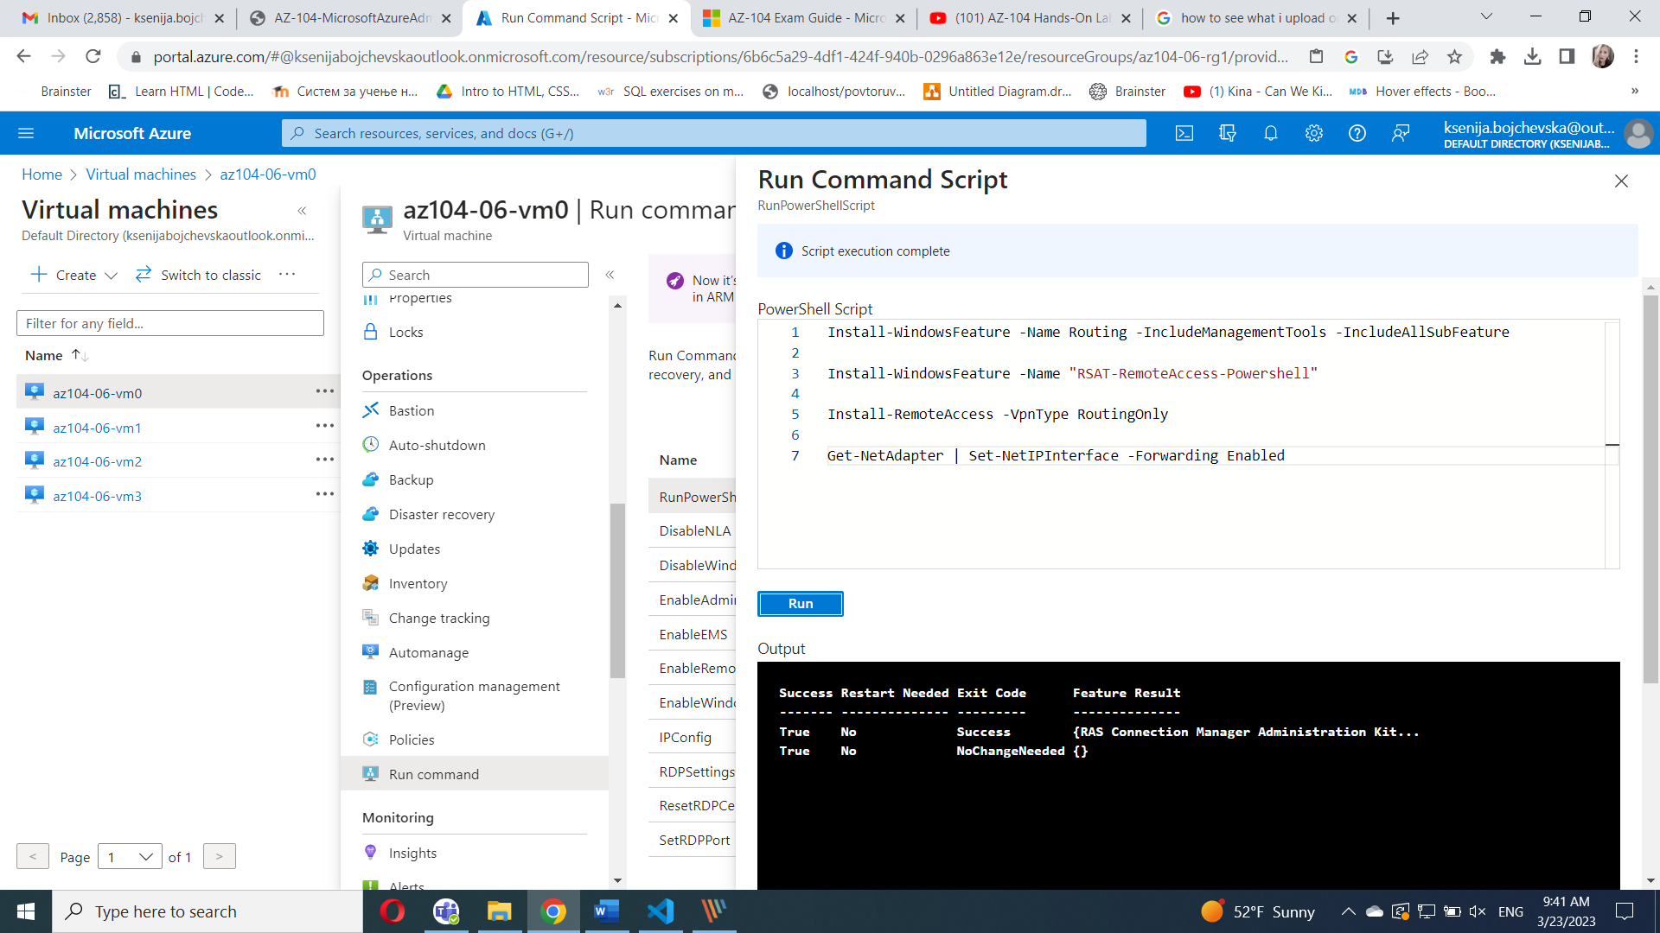

On  **Route tables** blade, **Create** **route table**

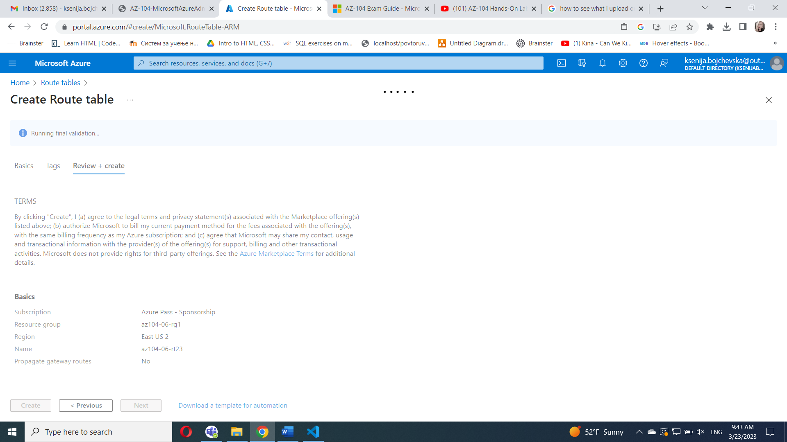

On the **az104-06-rt23** route table blade, in the **Settings** section,Add **Route and subnet**

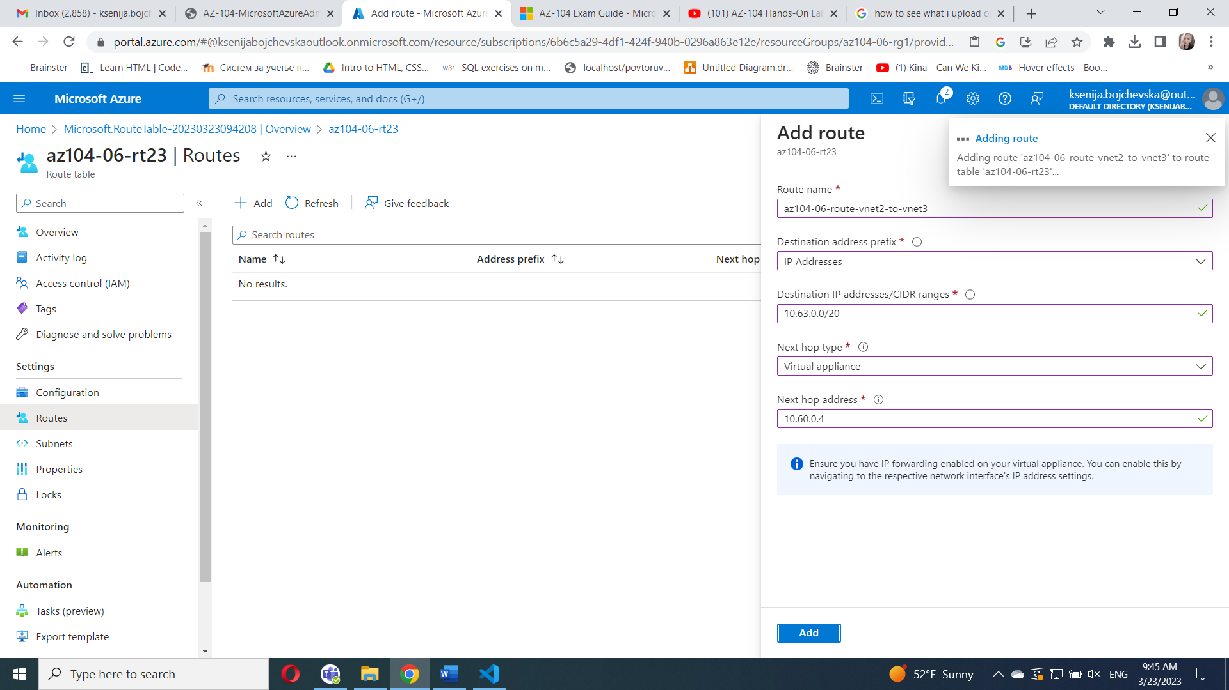

**Create Route table az104-06-rt32, route and subnet(same steps)**

On the **Network Watcher - Connection troubleshoot**  initiate a check



#### Task 5: Implement Azure Load Balancer

 Create **Load balancer**

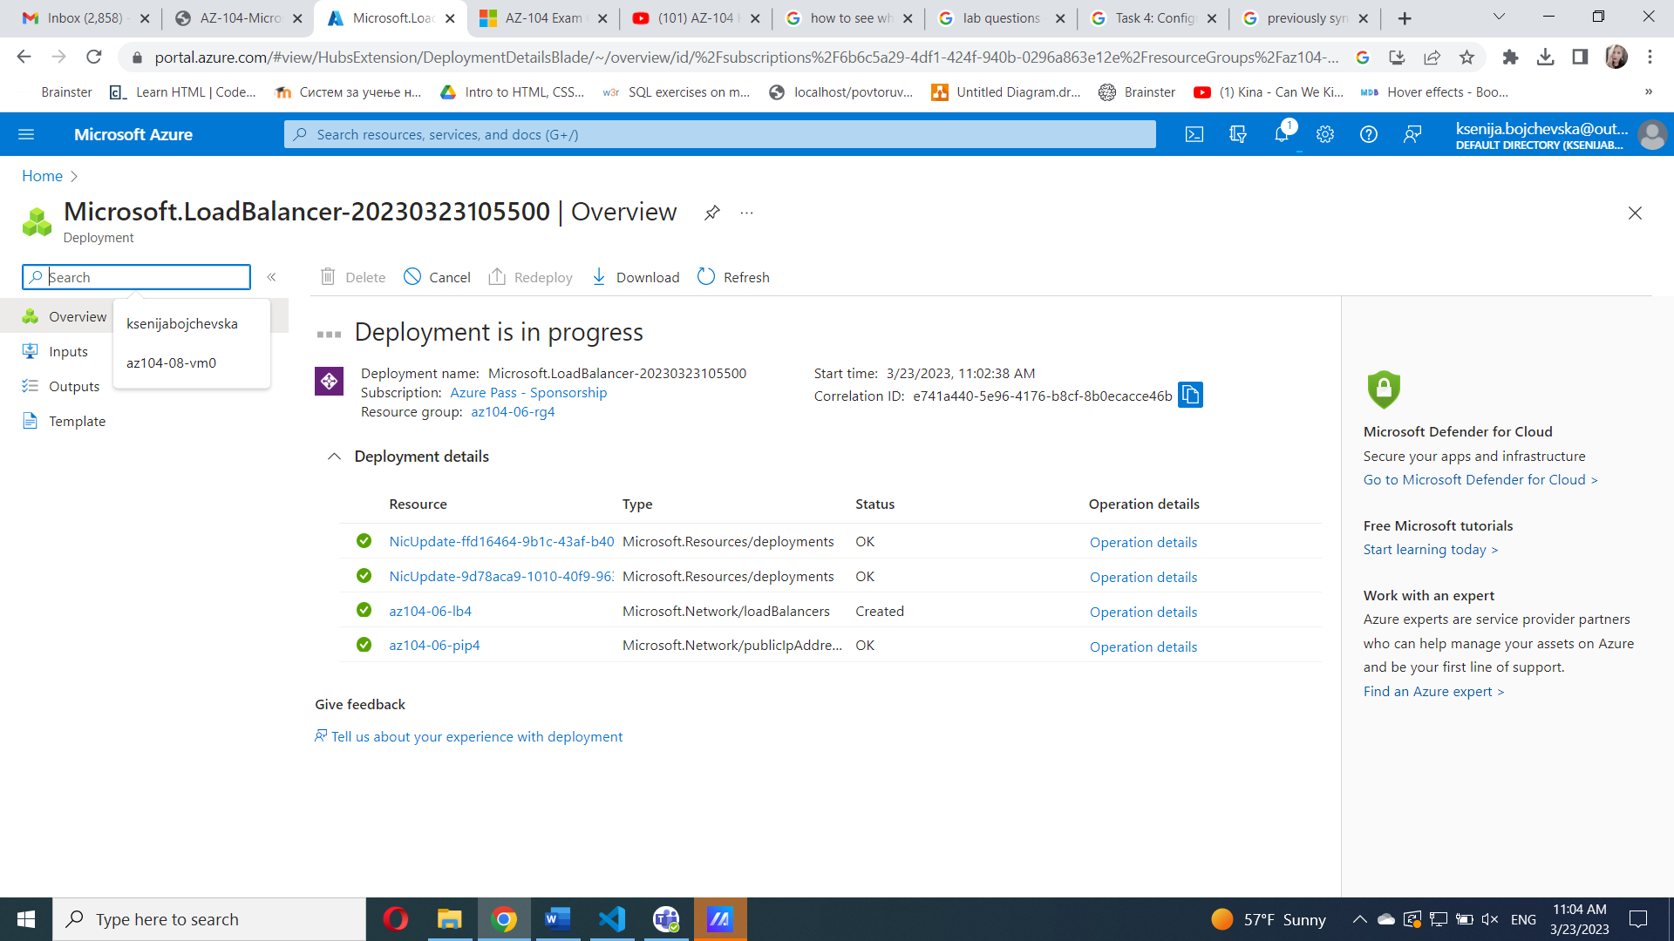

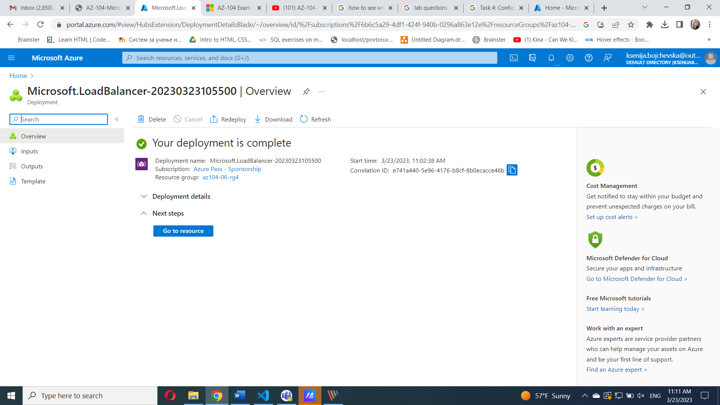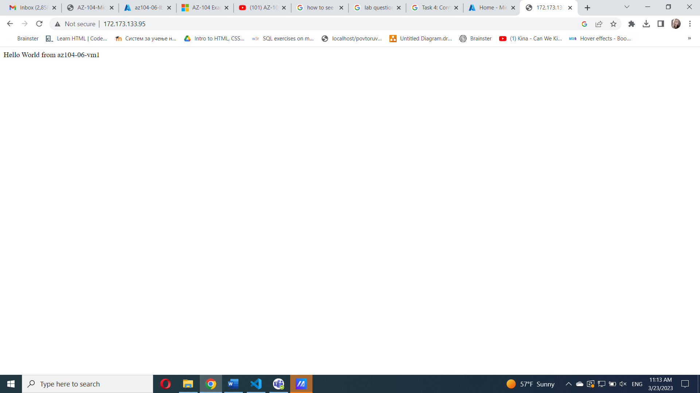

**Go to resource**, Select **Frontend IP configuration**

Copy the IP address and open another browser tab

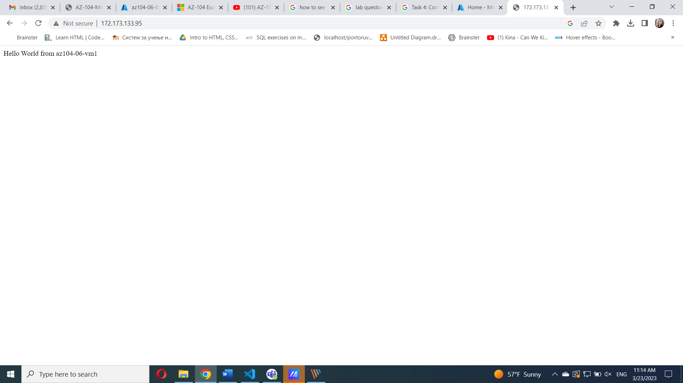

#### Task 6: Implement Azure Application Gateway

select **Virtual networks**, click **az104-06-vnet01, create subnet**

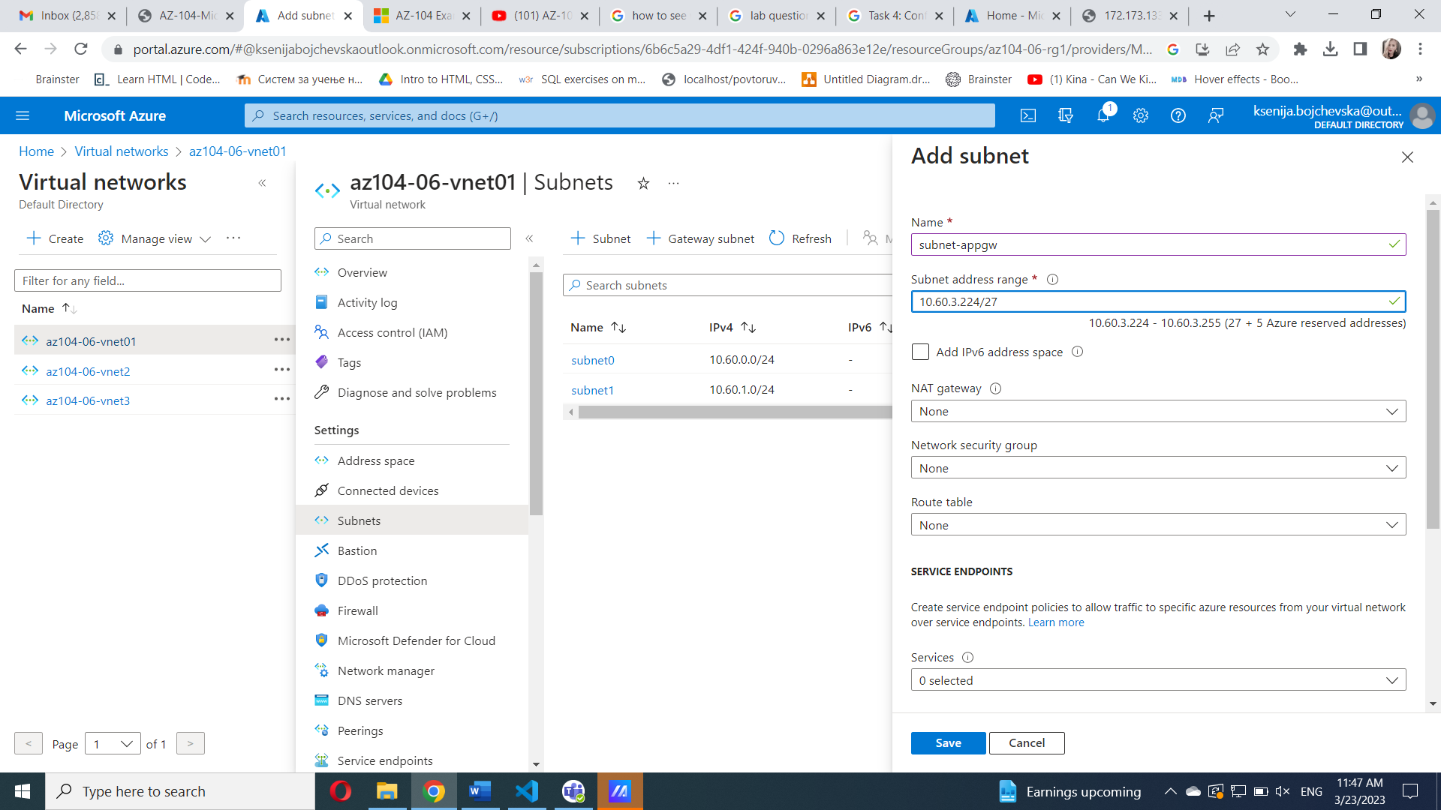

 Create **Application Gateway**

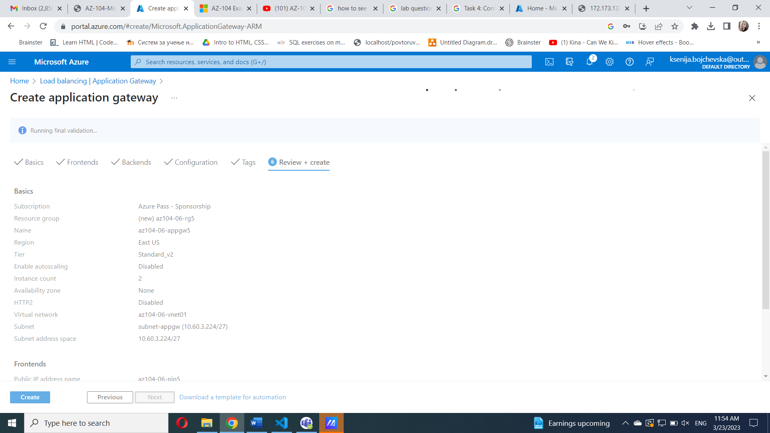

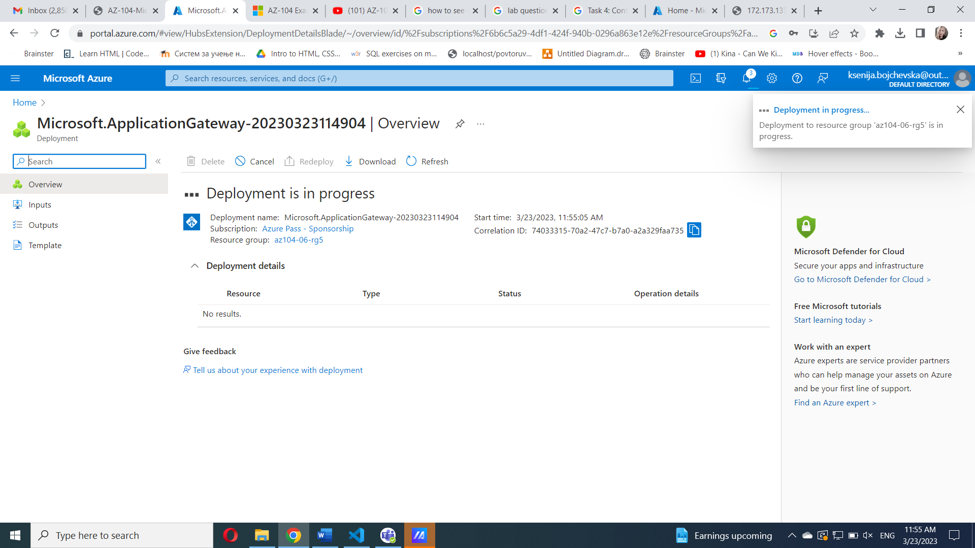

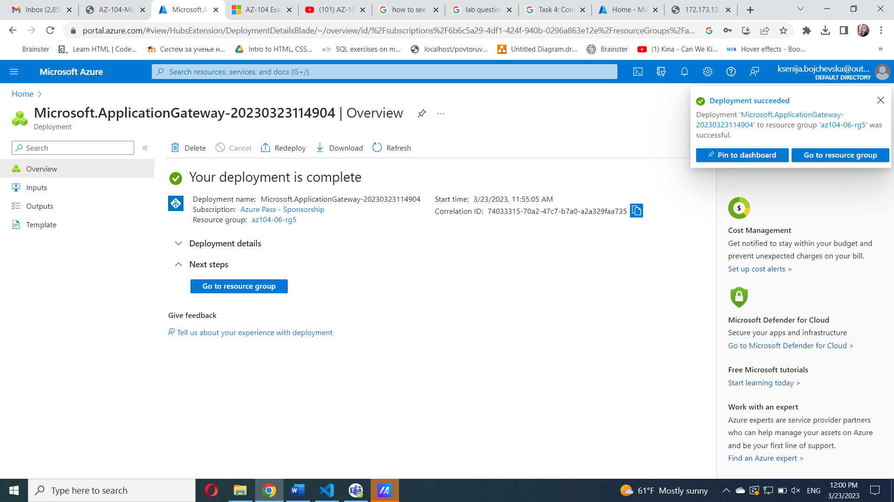

on the **Application Gateways** blade, click **az104-06-appgw5 open Frontend public IP address and copy**

Start another browser window and navigate to the IP address you identified in the previous step.

